The housing market and the case for higher inflation targets in the US and the Eurozone
Joshua Aizenman Menzie D. Chinn

15 May 2012

Might more inflation be good for the US and Europe? This column looks at the housing market in the US and argues that, with houses dropping in price, buyers are playing a waiting game. And as buyers keep delaying, the price drops further. Given the importance of property in many economies, the knock-on effects are severe. Yet one way to break this vicious cycle is with inflation.

The eloquent advocacy for moderate inflation at times of peril goes back to Irving Fisher’s seminal paper on the debt deflation:

“In summary, we find that: (1) economic changes include steady trends and unsteady occasional disturbances which act as starters for cyclical oscillations of innumerable kinds; (2) among the many occasional disturbances, are new opportunities to invest, especially because of new inventions; (3) these, with other causes, sometimes conspire to lead to a great volume of over-indebtedness; (4) this, in turn, leads to attempts to liquidate; (5) these, in turn, lead (unless counteracted by reflation) to falling prices or a swelling dollar; (6) the dollar may swell faster than the number of dollars owed shrinks; (7) in that case, liquidation does not really liquidate but actually aggravates the debts, and the depression grows worse instead of better, as indicated by all nine factors; (8) the ways out are either via laissez faire (bankruptcy) or scientific medication (reflation), and reflation might just as well have been applied in the first place.” Fisher (1933)

This visionary paragraph remains fresh today, particularly at times when the global crisis showed the perils of debt deflation in the US from 2008, and in Europe from 2010. The residential housing market in the US is a prime example of the acidic power of housing deflation.

- The evolution of the S&P/Case-Shiller home price indices, shown Figure 1, vividly illustrates the fact that real estate deflation is not over.
- After a brief and ultimately illusory recovery in 2010, the deflationary trend is back.
- The pending home sale index confirms sales remain in hibernation (see Figure 2).

Figure 1. Case-Shiller home price index growth rates. Source: S&P.
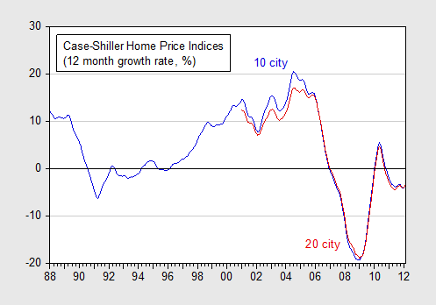

Figure 2. US pending home sales index, 2001-2012

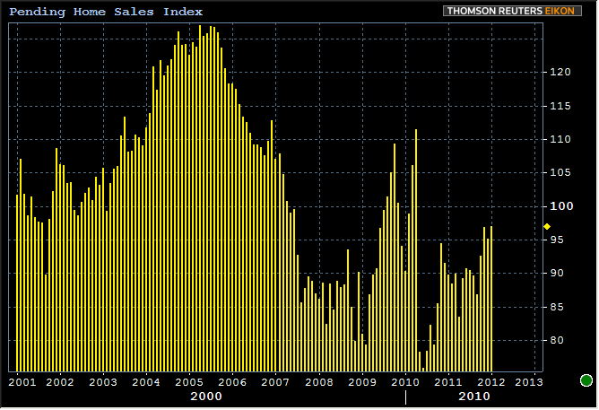

Delaying housing purchases boosts the incentive to delay
The option-value approach to durable goods implies that housing price deflation and low sales are intertwined. When the odds for housing deflation remain high, households have the incentive to delay purchase, even if they have good access to financing. The zero bound on the nominal interest rate implies that low interest rates may not offset the exposure to capital losses due to expected housing deflation. This configuration may lead to a housing market trap – households engage in a waiting game, delay their purchase, and thereby induce yet faster housing deflation, probably provoking other households to delay their purchase. This in turn pushes more houses to be ‘underwater’, leading to more foreclosures, more fire sales, and so forth.

The social cost of degrading neighbourhoods, where deeper foreclosures reduce the value of other houses, is by now visible in the worst affected states in the US. These dynamics validate the notion of ‘fire-sale externalities’, as well as Fisher’s observation “liquidation does not really liquidate but actually aggravates the debts, and the depression grows worse instead of better.” The laissez faire bankruptcy way of dealing with housing adjustment turned out to be highly inefficient in the US residential market.

This leaves Fisher’s ‘reflation’ option as a viable policy to shorten the painful debt deflation in the US. The logic is simple – moderate inflation for several years would terminate at an earlier juncture the buyer’s ‘waiting game’ in the housing market. Once the deflationary dynamics end, the pent-up demand for houses will be released. The timing game will switch from waiting to ‘rush to buy’. Chances are that this will signal the end of the housing slump, and will invigorate construction.

For the US, there is strong statistical evidence that higher inflation increases household net equity in housing. Over the period 1957 to 2001 (just before the housing boom), net housing equity rose faster with inflation; each one percentage point increase in the price level was associated with around a 1.15 percentage point increase in equity, after controlling for income growth.

Pros and cons of non-recourse mortgage loans
Figure 3. US and Spain housing prices, 1997-2010. Source: BIS, Annual Report.
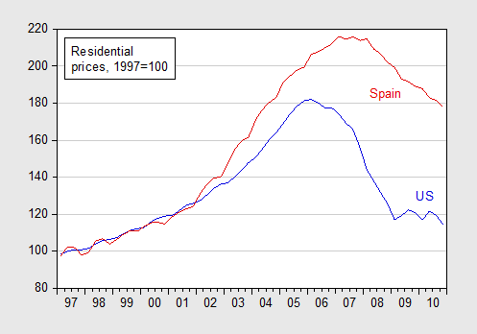

The logic of low inflation may be even more compelling for the Eurozone. Figure 3 compares the real estate adjustment of Spain and the USA. Intriguingly, the real estate prices have declined at a markedly slower pace in Spain than in the US. This probably reflects the predominance of the non-recourse mortgages in the US, versus the recourse mortgages in Spain. While the recourse system provides more bargaining clout to the lender, it tends to make the housing price adjustment more protracted in recessions, probably prolonging the resultant debt-deflation. Thus, a recourse system that ex ante may be more efficient in providing deeper financing to marginal households, comes with a higher ex post social cost due to the negative externalities unleashed with debt deflation. This configuration traps Spain into a longer period of sluggish performance, implying that the potential benefit of moderate inflation in Spain may be even higher than in the US. This argument has even more bearing if Spain is the victim of multiple equilibria, where the growing pessimism in the Eurozone pushes Spain to the bad equilibrium (see De Grauwe and Ji 2012).

Historically (that is, up to 2003), inflation explained a larger proportion of Spanish house prices than even in the US (Tsatsaronis and Zhu 2004). This finding reinforces the argument for an inflation-based approach to reducing the debt overhang in that country.

A concern about inflation is that it comes with its own costs. Yet, there is no clear cut evidence that moderate inflation, at and below 5%, has sizable social costs¹. The well-known study of Bruno and Easterly (1998) vividly illustrated the risk of approaching two digits inflations, yet targeting inflation at or below 5% leaves ample room for stabilising inflationary bursts when inflation reaches a range above 5% and below 10%. Of course, the case of Spain is more problematic, as the inflation there is controlled more by the ECB than by Spain. Yet, Fisher’s debt deflation concerns are as powerful in the Eurozone as in the US. Chances are that, with a lag, a moderate inflation in the US would change the mind-set in Europe, and that hastening the global recovery would generate positive feedback effects between the euro and the dollar zones.

References
Aizenman J and N Marion (2009), “Using inflation to erode the US public debt”, Journal of Macroeconomics, 33:524-541.
Blanchard, O, C DellAriccia, P Mauro (2010), “Rethinking macro policy”, VoxEU.org, 16 February.
Bruno M and W Easterly (1998), “Inflation Crises and Long-Run Growth”, Journal of Monetary Economics, 41(1):3-26.
De Grauwe P and Y Ji (2012), “Mispricing of sovereign risk and multiple equilibria in the Eurozone”, VoxEU.org, 23 January.
Rogoff, K (2011), “The bullets yet to be fired to stop the crisis”, Financial Times, 8 August.
Tsatsaronis, Kostas and Haibin Zhu (2004), “What drives housing price dynamics: cross-country evidence”, BIS Quarterly Review, March.
Fisher, Irving (1933), “The Debt-Deflation Theory of Great Depressions”, Econometrica.

1This argument is in line with earlier calls for moderate inflation. Olivier Blanchard, chief economist at the IMF, has argued that a 2% inflation target may be too low. He recommends targeting a higher inflation rate of about 4%. Ken Rogoff, a former chief economist at the IMF, has suggested that a moderate inflation for several years may have some merit (FT 2011). Aizenman and Marion (2009) point out that in many respects, the temptation to inflate away some of the public debt burden in the US today is similar to that at the end of World War II, the last time that the US debt/GDP exceeded 100%. About 30% of that ratio was reduced by moderate inflation during 1945-1954, at times of solid growth and recovery of the US economy.

Top of Form
Bottom of Form

