On the contribution of monetary policy to economic fluctuations

Olivier Coibion
8 June 2011, VOX.EU

What effect do interest-rate changes have on economic growth? Most studies suggest that the answer is “not much”. This column points out that a lot of these studies use US data from the early 1980s when monetary policy was under the “Volcker experiment”. When this episode is excluded, this column finds that the implied contribution of policy shocks to historical US business cycle fluctuations is much larger than found in much of the literature.

With fiscal policy locked in austerity and retrenchment programmes in many of the world’s advanced economies, monetary policy has become more important than ever. But how effective is it?
A central question in monetary economics is the sensitivity of the economy to interest-rate changes. Much of the evidence on the quantitative effects of interest-rate changes has come from time-series tools (namely, vector auto-regressions or VARs) which statistically model the joint dynamics of interest rates and other macroeconomic variables by projecting these series on lags of themselves and each other.

The predominant finding has been that the effects of unexpected monetary policy changes are relatively small and exogenous shocks to monetary policy instruments account for a small fraction of economic fluctuations.¹ Romer and Romer (2004) propose an alternative approach based on controlling for the central bank’s real-time forecasts and find that effects of monetary policy changes on production are approximately six times larger than typical estimates. This dramatic cacophony in the assessment of the contribution of monetary policy innovations to fluctuations has been both puzzling and surprisingly understudied.

In a recent paper (Coibion 2011), I argue that the period in which the Federal Reserve abandoned targeting the Federal Funds Rate between 1979 and 1982, also known as the “Volcker experiment,” can account for much of the differences in the results across methods. Because both the VAR and the Romer-and-Romer approaches treat the interest rate – which was exceptionally volatile during this period as a result of market-driven fluctuations – as the policy instrument, the period of non-borrowed reserves targeting introduces potentially significant errors in the estimation of monetary-policy shocks.

With and without the “Volcker experiment”
Figure 1 below illustrates the quantitative importance of either including or excluding the Volcker experiment in the estimation of the dynamic response of macroeconomic variables to monetary-policy shocks. The left panel plots the implied response of industrial production to an exogenous 100 basis point increase in the interest rate drawn from a standard VAR as well from Romer and Romer’s (2004) approach using data from 1969 to 1996 along with one standard deviation confidence intervals.
- With the standard VAR, a 100 basis-point increase in the interest rate leads to a peak drop in industrial production of 0.7%.
- The equivalent estimate using the Romer and Romer (2004) methodology is of a 4.3% drop in production.
- Once one omits the Volcker experiment, on the other hand, the two estimates become statistically indistinguishable and point to a peak effect on production of approximately 2.5% occurring more than two years after the change in policy.

The Romers are closer
Despite the fact that the predicted real effects of monetary policy shocks are significantly smaller than those originally documented by Romer and Romer (2004), the implied contribution of policy shocks to historical US business cycle fluctuations is nonetheless much larger than found in much of the literature using VARs.

Figure 1. Monetary policy with and without the “Volcker experiment”
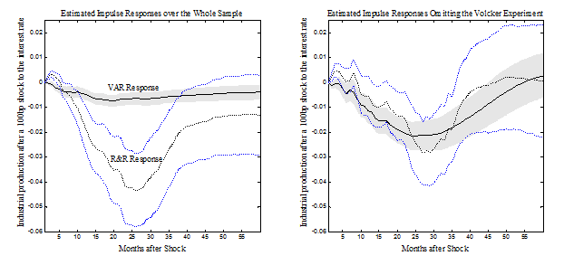

Figure 2 below plots actual changes in US industrial production and those predicted from the Romer and Romer (2004) shocks, after adjusting the dynamics for the Volcker experiment. Exogenous monetary-policy changes accounted for a significant component of real fluctuations, particularly in the 1970s and early 1980s. This finding stands in sharp contrast to the prediction of a standard VAR (also illustrated in Figure 2) and lends further credence to the view that improved monetary policy (in this case via smaller shocks) has contributed to the reduced volatility observed since the early to mid- 1980s.

Figure 2. Changes in US industrial production vs. forecasted changes from monetary policy shocks
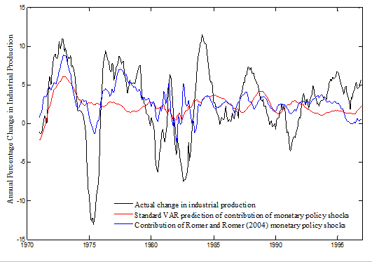

Conclusion
In summary, although properly measuring the stance of policy and identifying policy innovations is rife with difficulties, shocks to monetary policy appear to have a significant effect on the economy with the effect being approximately half-way between extremes suggested in the literature.
The apparent sensitivity of the results to the period of non-borrowed reserves targeting during the early Volcker years presents a cautionary tale for future monetary-policy analysis that will have to wrestle with the current period of zero interest rates and the associated unorthodox monetary-policy actions pursued by the Federal Reserve and other central banks.

References
Bernanke, Ben S, Mark Gertler, and Mark Watson (1997), “Systematic Monetary Policy and the Effects of Oil price Shocks”, Brookings Papers on Economic Activity,1:91-142.
Bernanke, Ben S, Jean Boivin, and Piotr Eliasz (2005), “Measuring the Effects of Monetary Policy: A Factor-Augmented Vector Autoregressive (FAVAR) Approach”, Quarterly Journal of Economics, 120(1):387-422.
Bernanke, Ben S and Ilian Mihov (1998), “Measuring Monetary Policy”, Quarterly Journal of Economics, 113(3):869-902.
Christiano, Lawrence, Martin Eichenbaum, and Charles Evans (1999), “Monetary Policy Shocks: What Have We Learned, and To What End?”, in John B Taylor and Michael Woodford (eds.), Handbook of Monetary Economics,65-148, Elsevier Science.
Coibion, Olivier (2011), “Are the effects of monetary policy shocks big or small?”, NBER Working Paper 17034.
Leeper, Eric M, Christopher A Sims, and Tao Zha (1996), “What Does Monetary Policy Do?”, Brookings Papers on Economic Activity, 1996(2):1-78.
Romer, Christina D and David H Romer (2004), “A New Measure of Monetary Shocks: Derivation and Implications”, American Economic Review, 94:1055-1084.

¹ See for example Leeper et al. (1996), Bernanke et al. (1997), Bernanke and Mihov (1998), Christiano et al. (1999), and Bernanke et al. (2005).

