Emerging market resilience

Tatiana Didier Constantino Hevia Sergio Schmukler
9 August 2011

The global crisis of 2008-09 hit emerging markets nearly as hard as it hit rich countries, which is welcome news compared to previous crises in which emerging markets often suffered much more than developed economies. This column explores emerging economies' growth dynamics since the crisis.

According to popular perception, emerging economies fared substantially better than advanced countries during the Great Recession. For example, studies show that advanced countries attained lower rates of GDP growth during the crisis even after taking account of the usual controls (e.g. Frankel and Saravelos 2010; Rose and Spiegel 2010).

However when we look at collapses in GDP growth, the evidence suggests that, on impact, the crisis hit emerging and advanced countries equally hard. This approach has been taken by several influential studies (Blanchard et al. 2010; Claessens et al. 2010; Lane and Milesi-Ferretti 2010),

In a recent paper (Didier et al. 2011), we argue that emerging countries suffered declines in real GDP growth comparable to, or even larger than, those in advanced countries. Moreover countries rebounded in the aftermath mostly according to how deep their collapse had been. In particular, we identify a non-linearity between the collapse in GDP growth and GDP per capita. The largest growth collapses tended to occur in the wealthier emerging countries and poorer high-income economies.

In an important sense, this is good news. Unlike earlier crises, where emerging nations often fared much worse than developed nations, this time the shock had similar effects. Moreover, emerging nations were able to use a larger set of policy tools. There is, of course, heterogeneity among emerging nations. Eastern Europe and Central Asia fared the worst. In the case of low-income countries, their relatively lower degree of trade and financial openness helped shelter them from the worst declines in output growth.

GDP growth performances compared
The length of the recession and the post-crisis performance is one area where emerging economies did fare better, partly because of structural reasons and partly because their policies worked in their favour this time around.

Based on relatively high-frequency industrial production data, Figure 1 shows that the number of months that emerging economies were under recessionary pressures was smaller than that of advanced countries. For example, by September 2009, emerging countries, as a group, achieved their pre-crisis levels of industrial production, while advanced countries were still well below their pre-crisis level, even by the end of 2010. Moreover, while advanced countries were able to return to their pre-crisis growth rates by January 2010, emerging economies enjoyed by then even higher growth rates than before the crisis, allowing them to return faster to their trend output level. For example, while industrial production in advanced economies was over 16 percentage points below trend in November 2010, it was only 7 percentage points below trend in emerging economies at that time.

Figure 1. Industrial production
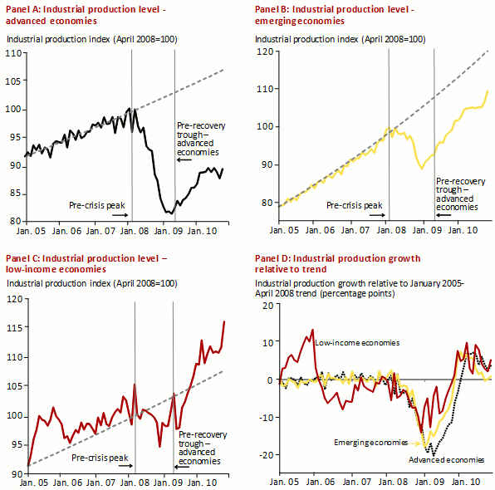
Notes: This figure shows industrial production (IP) during the 2008-2009 crisis across income levels. Panel A, B, and C show the IP level, indexed to 100 in April 2008, and the IP level pre-crisis trend for the three income levels. The pre-crisis trend for each income level is constructed by calculating the pre-crisis compounded annual growth rate between January 2005 and April 2008, and extrapolating it until the end of the sample. Panel D shows the evolution of year-on-year (YOY) IP growth relative to the pre-crisis average YOY IP growth. Pre-crisis average YOY IP growth is calculated across the January 2005-April 2008 period. IP data come from the World Bank's Global Economic Monitor. Income level averages are weighted by 2007 nominal GDP in U.S. dollars from the World Economic Outlook (October 2010). Advanced economies are economies classified as "High Income" under the World Bank July 2010 classification (both OECD and non-OECD). Economies are classified as emerging if they have access to IBRD financing, and as low income if they only have access to IDA financing.

Four factors seem to be behind the differentiated post-crisis behaviour of emerging-market countries, relative to their past and to advanced economies.
- The first and most obvious one is that the root of the problem was in the financial markets of advanced countries and that developing countries had a low exposure to these markets relative to other developed countries. At the same time, the financial collapse hit highly leveraged consumers in some developed countries, while consumption was posed to continue growing at a high rate in emerging countries.
- The second reason is that one of the main crisis transmission channels seems to have been international trade. As the US economy came to a standstill in the fourth quarter of 2008, firms stopped their international orders anticipating an accumulation of inventories (due to the orders already being processed and shipped). This generated an immediate collapse in production in several emerging economies focused on supplying manufactures to the world economy. As inventories started to decrease and it became more likely that global demand would stabilise and the crisis would not be transmitted in full to emerging economies, firms reignited the production process and overall economic activity in emerging markets picked up. Thus emerging economies were able to generate a faster recovery than developed countries (for which manufacturing accounts for a smaller share of total activity).
- The third reason is that, to the extent that emerging economies grow at a higher pace in their path to become richer nations, a recovery of their growth trajectory would make their output converge sooner to the pre-crisis level.
- The fourth reason for the better post-crisis performance of emerging economies, at least relative to their previous history, is a fundamental change in the way these countries have conducted their policies in the recent past. In effect, the behaviour of emerging countries during the global crisis might come as a surprise given previous experiences during turmoil periods, when foreign shocks tended to end up as full-blown domestic crises. But a change in the policy stance seems to have taken place in the late 2000s (Gourinchas and Obstfeld 2011; Kose and Prasad 2011). More countercyclical policies were pursued before and during the global crisis. Furthermore, as opposed to previous crises, the resilience of countries to the 2008-09 crisis might be partly attributed to a combination of sounder macroeconomic and financial policy frameworks and a shift towards safer domestic and international financial stances. The global crisis found many emerging countries with more fiscal space, better balance sheets, and the required credibility to conduct expansionary fiscal and monetary policies.
In sum, given the scale of the global crisis, it was difficult for emerging countries to decouple from the world economy at the same time that they were part of the global production system, used foreign funds to finance investments, and held assets abroad. Any significant collapse of global demand and in the financial centres was likely to get transmitted to all countries linked to them. Emerging economies fell in this category.

The continuing integration to global trade and global financial markets poses trade-offs to developing countries. While integration tends to be associated with higher growth and other positive traits, it also makes countries vulnerable to foreign shocks and contagion effects. Given these risks, emerging countries would probably try to keep improving their external positions, saving more, accumulating reserves, expanding their fiscal space, reducing credit mismatches, building buffers in the financial system, and gaining confidence and credibility in their monetary and financial policies, among other things. These policies seemed to have been helpful during the global downturn and the incentives for emerging countries to stay in the same path only became more obvious. Unfortunately, some of these policies entail pecuniary and opportunity costs, like the costs of hoarding reserves, those related to developing local currency and long-term debt markets, and those implied by a slowdown in the growth rate of credit and consumption. Moreover, the actions by some countries have some negative spillover effects on other countries. For example, by limiting foreign capital inflows some countries might push capital to neighboring countries, exerting more pressure on their currencies. In a world where goods and capital continue to flow increasingly across nations, future research might help us understand the general equilibrium effects of the policies adopted to deal with globalisation.

References
Blanchard, O, H Faruqee, and M Das (2010), “The Initial Impact of the Crisis on Emerging Market Countries”, Brookings Papers on Economic Activity,Spring:263-307.
Claessens, S, G Dell’Ariccia, D Igan, and L Laeven (2010), “Cross‐Country Experiences and Policy Implications from the Global Financial Crisis”, Economic Policy,62:267-293.
Didier, T, C Hevia, and S Schmukler (2011), “How Resilient Were Emerging Economies to the Global Economic Crisis?”, World Bank Policy Research Working Paper 5637.
Frankel, J, and G Saravelos (2010), “Are Leading Indicators of Financial Crises Useful for Assessing Country Vulnerability? Evidence from the 2008–09 Global Crisis”, NBER Working Paper 16047, June.
Gourinchas, PO, and M Obstfeld (2011), “Stories of the Twentieth Century for the Twenty-First”, American Economic Association Annual Meeting, Denver, CO.
Kose, A, and E Prasad (2010), Emerging Markets: Resilience and Growth amid Global Turmoil, Washington, DC: Brookings.
Lane, P, and GM Milesi-Ferretti (2010), “The Cross-Country Incidence of the Global Crisis”, IMF Working Paper 10/171, July.

Rose, A and M Spiegel (2010), “Cross-Country Causes and Consequences of the 2008 Crisis: International Linkages and American Exposure”, Pacific Economic Review, 15(3):340-363.

