Mistaken monetary policy lessons from Japan?

John Muellbauer Keiko Murata
21 August 2011, VOX.EU

The global crisis of 2008-2009 has refocused attention on the lessons of Japan’s lost decade, with many suggesting that Europe and the US are heading the same direction. This makes a thorough understanding of the Japanese case an urgent matter. But this column argues that pushing the analogies too far is a mistake that could prolong the economic pain.

The dot-com crisis of 2000-2001 and the recent global crisis of 2008-2009 have refocused attention on the lessons of Japan’s lost decade (eg Kobayashi 2008). One lesson almost universally accepted is the need for rapid refinancing of the banking system after a financial crisis. But there are widespread worries that the monetary transmission mechanism in the US and other industrial economies might be as weak as it appears to have been in Japan. Many have suggested that America and Europe are in for their own lost decade. This makes a thorough understanding of the Japanese case an urgent matter.

New research on lessons from Japan
Monetary transmission via Japan’s household sector is sharply different from that operating in the US and other industrial countries, and hence why monetary policy analogies with Japan should not be taken too far. In recent research with our colleagues (Muellbauer and Murata 2011 and Aron et al forthcoming), we explain why. Indeed, pushing the analogies too far probably contributed to US monetary policy errors in 2002-05, which in turn deepened the crisis that followed.

Our research focuses on the empirical analysis of Japanese consumption and household saving behaviour and explains the role of the household sector in the monetary transmission mechanism in Japan. We find two major differences in Japan compared to the US and the UK.
- First, Japan has not experienced the kind of liberalisation of credit conditions for households seen in the US and the UK.

This is the main reason why the growth of debt relative to income has been much more moderate in Japan. With households rich in liquid assets minus debt, a fall in interest rates on deposits, given household income, reduces aggregate household spending in Japan. In contrast, US and UK households have held more debt than liquid assets in recent years, and a lower interest rate increases their spending, given household income.

- Second, the impact on consumer spending in Japan of higher house prices is negative, while in the US and UK it is positive.
This is mainly due to differences in mortgage markets and in the tax systems, which discourage home equity withdrawal in Japan but not in the US and the UK.

The research method
We develop models for aggregate consumption in Japan using the solved-out consumption function approach associated with Ando and Modigliani (1963) rather than the Euler equation approach of Hall (1978). There are three main reasons for this.
- First, the Euler approach ignores long-run information, and so is not useful for understanding historical experience.
- Second, it is sensitive to the failure of strong assumptions about consumer rationality.
- Third, the empirical evidence strongly rejects the central prediction of the theory.
Our model is more robust and incorporates forward-looking income growth expectations and income uncertainty proxies, and the special role of housing wealth, which tend to be neglected in most studies of the solved-out form. We also examine the impact of demography, which is an important issue for Japan. The model includes wealth- and interest-rate effects, and investigates the role of residential land prices.

A key feature, derived from inter-temporal consumption theory, is to use disposable non-property income rather than total disposable income as the key determinant of consumption in the long run. This is quite important, as property income measured in the national accounts is a poor measure of the income concept that follows from theory. For example, the decline in the saving ratio in the 1990s, despite lower asset prices, is partly the result of lower inflation and the reduction in measured property income in the national accounts—rather than, for example, being necessarily caused mainly by the ageing of the Japanese population.

The empirical findings
Based on our empirical results, we have a good explanation of why lower short-term interest rates do not stimulate total demand in the Japanese economy in the way they do, for example, in the US or the UK.

First, in the US and UK, there is an important asset-price channel, which, according to our estimated Japanese consumption function, is not just switched off in Japan, but even works in reverse. Using data going back to 1961, we find that real land prices have a negative effect on consumption in Japan, controlling for income, financial assets and debt, interest rates, and proxies for uncertainty and for income growth expectations. Thus, when real land prices rise, young households and other renters save more, partly because larger down-payments are then needed before a mortgage can be obtained and partly because future rents will be higher. This dominates the wealth effect for older households, which we believe is small partly because of the inheritance tax advantages in Japan of leaving housing assets to their children. For shorter sub-samples in which there is less variation in real land prices, this negative land price effect is weaker than for the full period. Nevertheless, for no period can we find a remotely significant positive effect from physical assets or real land prices on consumption.

Figure 1 illustrates the long-run effect on the ratio of consumption to non-property income of real land prices in Japan. This makes it clear that though the rise in land prices before 1990 lowered the consumption-to-income ratio, this was a relatively small effect. The research in Aron et al (forthcoming) shows that the comparable effects of house prices on the consumption-to-income ratio in the US and UK were positive and far larger and clearly linked to shifts in credit-market conditions. In these countries, higher housing collateral results in more borrowing and consumer spending. However, Figure 1 confirms the important role in Japan of the accumulation of net financial wealth in supporting the rise of consumption relative to income in the long run.¹

Figure 1. Estimated long-run contribution to log consumption-to-income ratio of the net financial wealth (NFW) to income ratio and log real land prices in Japan
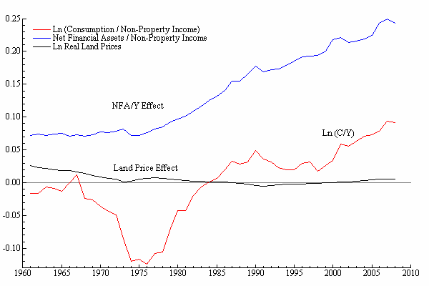
The UK mortgage market is dominated by adjustable-rate mortgages, so reductions in short-term rates feed through quickly into borrowing and house prices. First-time buyers in the UK until recently had access to close to 100% mortgages. As a result, saving for a down payment does not have the priority it has in Japan.

In Japan, lack of competition in banking, the dependence of banks on interest income (rather than fees and other sources of profits); and the non-performing loans problem have kept borrowing rates high relative to deposit rates. Japan did not experience credit-market liberalisation for households on the scale seen in the UK from 1980, and in the US over a longer period.

A second reason for the weak, or even perverse, interest-rate transmission mechanism for households in Japan comes from inter-temporal consumption theory. This says that households who are averse to fluctuations in consumption (who have a low elasticity of inter-temporal substitution) and a high asset-to-income ratio will experience positive effects on consumption from a rise in the real interest rate, while the opposite is likely to be true for households with the opposite characteristics.

Japanese households have among the highest asset-to-income ratios in the world, particularly for bank deposits. They may also be particularly cautious, so are more averse to fluctuations in consumption. Indeed, we find a very significant and robust positive real-interest-rate effect in our Japanese consumption function. Thus, the fall in short-term rates after 1993 had a negative direct effect on consumption spending in Japan. However, the later rise in real rates because of falling prices supported consumption. This contradicts the conventional Anglo-centric view that falling prices are a disaster for consumption. Figure 2 illustrates the sizable long-run effect of real interest rates on the consumption-to-income ratio in Japan. It suggests that the rise in real rates induced by price deflation after 1998 actually had a small positive effect on the consumption-to-income ratio.

Figure 2. Estimated long-run contribution to log consumption-to-income ratio of real interest rate and forecast income growth in Japan.
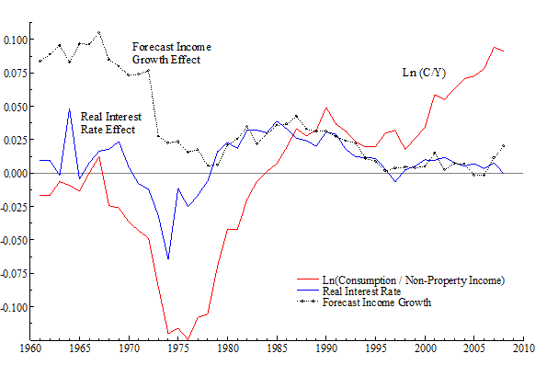

A possible alternative explanation for a positive real-interest-rate effect on consumption, which can be dismissed, is omitted variable bias. Suppose there had been substantial credit-market liberalisation, causing a rise in the ratio of consumption to income, and associated with a rise in real interest rates as credit rationing was replaced by market pricing of credit. We examine evidence from models for household debt to see if, between the late 1970s and the 1980s or later, there was any upward shift in debt that cannot be explained by conventional income, interest rate, and asset-price or wealth effects. UK and US evidence supports such shifts, but we find no such evidence for Japan.
Our research does not imply that the interest-rate channel is missing for the overall Japanese economy. Financial assets have conventional positive effects on household spending in Japan of a size consistent with theory and evidence for other countries. Theory predicts that lower interest rates have a positive effect on financial asset prices. But this is offset by the negative direct effect of lower real interest rates on consumption, and the negative indirect effect via higher land prices. Thus, the overall interest channel is far weaker than in the UK or the US.

It is important to emphasise that our research does not suggest that raising the policy rate will stimulate economic activity in Japan. Evidence from forecasting models for GDP in Japan show that reductions in nominal interest rates do have a positive effect on output at a one-year horizon. This is consistent with investment, and probably exports, responding in the conventional way to lower interest rates and the financial asset price changes they induce.

Fiscal policy effectiveness
Our GDP and income forecasting work has important implications on the efficacy of fiscal policy in Japan. We find significant negative effects from fiscal debt-to-GDP ratios in on future growth of GDP and household income, while similar models for the US find far weaker effects. The forecasts from these models are significant in explaining consumption growth, and suggest that there is an important ‘Ricardian’ element in the behaviour of Japanese households. In other words, it appears that Japanese households have some understanding of the fact that high levels of government debt will raise future tax rates or lower future government spending which could have benefitted households. Figure 2 illustrates the effect of forecast income growth on the consumption-to-income ratio, making a large contribution to the decline in the ratio in the 1970s. The figure shows the effect on the consumption-to-income ratio of the subdued level of forecast growth in the post-bubble period.

Conclusions
The implication is that the effectiveness of both fiscal and monetary policy has been limited in Japan in recent years. This is not perhaps a surprising result, but we provide theoretical and econometric evidence to explain the role of households in this fact.

Credit availability for US and UK households has contracted relative to the excesses before the financial crisis, so that in this respect, differences from Japan have diminished. While this implies that the transmission, via households, to economic activity of the interest rate set by monetary policy in the US and the UK is now somewhat weaker than it was before, the differences from Japan far outweigh the similarities.

References
Ando, Albert and Franco Modigliani (1963), ‘The ‘Life Cycle’ Hypothesis of Savings: Aggregate Implications and Tests’, American Economic Review, 53:55-84.
Aron, Janine, John Duca, John Muellbauer, Keiko Murata and Anthony Murphy (forthcoming), ‘Credit, housing collateral and consumption in the UK, US, and Japan’, 2010, CEPR Discussion Paper 7876, revised version forthcoming Review of Income and Wealth.
Hall, Robert E (1978), ‘Stochastic Implications of the Life Cycle-permanent Income Hypothesis: Theory and Evidence’, Journal of Political Economy, 86(6):971-987.
Kobayashi, Keiichiro (2008), ‘Financial crisis management: Lessons from Japan’s failure’, VoxEU.org, 27 October.
Muellbauer, John and Keiko Murata (2011), ‘Consumption, Land Prices and the Monetary Transmission Mechanism in Japan’, Chapter in K Hamada, AK Kashyap and DE Weinstein (eds.), Japan’s Bubble, Deflation and Long-term Stagnation,(MIT Press 2011), p.175-216. Revised version of CEPR DP available here.

¹ Incidentally, while changing demography appears to have little effect on aggregate consumption in Japan given wealth, it does appear to have an indirect effect on consumption via wealth.

