Anaemia, exuberance, and vulnerability: A post–financial crisis new global economic geography
Ignacio Munyo Ernesto Talvi
27 October 2011, VOX.EU

The global crisis crippled advanced economies, but it also freed up financial resources that flooded emerging markets. This column introduces an index to identify the post-crisis winners and losers, digging into the causes of the new economic geography and exploring the vulnerability of emerging economies to a recurrence of a Lehman-type virus.

It would not be an overstatement to assert that the global financial crisis has created a ‘new global economic geography’, a new reality that responds to the remarkable fact that the crisis that has crippled advanced economies has also left winners around the globe.

Winners and losers
This remarkable phenomenon is suggested by the sharp contrast in macroeconomic performance in the US and the EU compared to some key emerging economies such as China, India, and Brazil. The aftermath of the financial crisis in the US and the EU came hand-in-hand with a severe credit crunch; an equally severe and persistent decline in private consumption, investment, and output relative to pre-crisis trends; a significant rise in unemployment and disinflationary pressures; and a depreciation of the dollar and the euro on a trade-weighted basis.

In other corners of the world (China, India, Brazil, etc), the picture that emerges is the exact opposite. Output is above pre-crisis trends and unemployment rates are low and declining. Both components of domestic demand – consumption and investment – are also above pre-crisis trend levels, fuelled by a very rapid acceleration in bank credit flows. As a by-product, these three countries had to face up to inflationary pressures and a significant real appreciation of their currencies against the dollar and on a trade-weighted basis.

This sharp contrast is not a mere coincidence – it is causally connected. The genesis of the new economic geography lies in the financial crisis in advanced economies. Depressed consumption and investment freed up capital and financial resources that flooded a broad spectrum of emerging markets across the world.

This new economic reality clearly suggests that the global financial crisis that erupted in early 2007 in the obscure corner of the US credit market now infamously known as subprime mortgages has produced both winners and losers, ie, countries that appear to be better off and countries that are significantly worse off relative to the trends prevailing prior to the crisis.

CERES Global Index of Economic Exuberance
To identify who are the winners, who are the losers, and why, we develop the CERES Global Index of Economic Exuberance, designed to measure whether a country’s macroeconomic performance is stronger or weaker relative to its performance prior to financial crisis of 2007.¹

Our index gauges the behaviour of six key macroeconomic variables – output, unemployment, domestic demand, bank credit, inflation, and the real exchange rate – for 42 advanced and emerging economies covering every region of the world.
According to the index the post-crisis world is divided into two groups:
- Countries with a positive index, which we define as ‘exuberant economies’, and
- Countries with a negative one, which we define as ‘anaemic economies’.

The anaemic economies mostly include advanced economies and those emerging regions that are closely connected to them, ie emerging Europe and Mexico and Central America. On the other hand, in the exuberant economies category we find mostly the emerging economies of South America, emerging Asia, sub-Saharan Africa, and the Middle East and North Africa (see Figure 1).
Figure 1. Global Index of Economic Exuberance (by region)
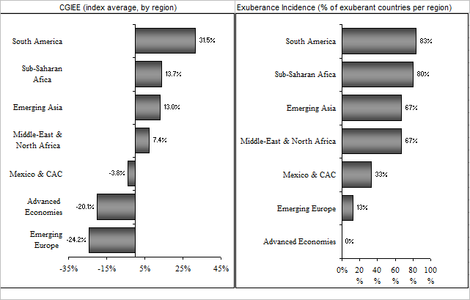

Surprisingly, for exuberant economies with large positive index values, the first positions are dominated by Latin American countries (Argentina, Brazil, Panama, Peru, and the Dominican Republic) and African countries such as Angola, rather than emerging Asian countries. India and China rank high but appear in the 8th and 9th position, respectively (see Figure 2).

Figure 2. CERES Global Index of Economic Exuberance(by country)
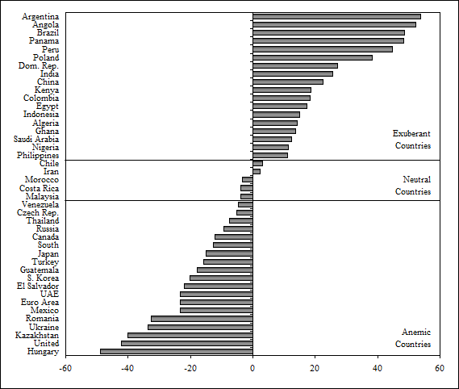
Exuberance and anaemia are a rather generalised phenomenon that spreads across the whole set of macro variables composing the index. The average exuberant economy not only displays a positive value of the index but also displays positive values in each of the six components. Something similar occurs with the average anaemic economy. It displays an overall negative value of the index and negative values in every one of the components.

Cluster analysis: Exuberant and anaemic economies
To dig further into the causes of why some emerging countries turned out to be winners and others to be losers, we perform formal statistical cluster analysis. This analysis unveils that emerging countries that share some key structural characteristics became the winners in the new economic geography:
- Net commodity exporters, who benefited from historically high commodity prices;
- Countries that export a significant share of their goods and services to exuberant economies;
- Countries with low dependence on remittances flowing from advanced anaemic economies;
- Countries with relatively ample opportunities for investment in capital-intensive and interest rate–sensitive sectors in the economy (and a relatively favourable domestic investment climate), that benefited from cheap and abundant capital and financial resources.²
To summarise, the index projects an image of a new economic geography that splits the world into exuberant and anaemic economies.
This divide escapes any easy classification, cutting across economic development categories, geographical regions, or the East-West dimension.
- First, although exuberant economies are mostly emerging markets and anaemic economies are advanced countries, many emerging markets still fall into the anaemic category.
- Second, there is diversity within geographical regions, each of them displaying their fair share of both exuberant and anaemic economies.
- Third, the US and the EU are classified as anaemic whileChina and many countries in Asia are classified as exuberant economies, but it is not a clear East-West separation.
Japan is also in the anaemic group, while countries in South America and Africa are of the exuberant type.

This new configuration of the world economy implies a more complex redistribution of economic power and a new web of economic relations (and maybe also of geopolitical interests) than a simple East-West dichotomy might suggest.

External vulnerability in emerging markets
Although the new global economic geography has been largely beneficial for emerging countries, it has come at a price. As we stated before, its genesis lies in the financial crisis in advanced economies that freed up capital and financial resources to be reallocated to emerging markets. However, the financial crisis and its collateral damage are far from being resolved, and subject the world capital markets to recurrent episodes of financial turmoil.
Moreover, current instability in global markets occurs in a context where huge fiscal deficits and explosive paths of public debt have weakened the advanced economies’ ability to respond to a new wave of severe financial turbulence as effectively as they did in the initial stages of the crisis. This fact makes a new crisis episode potentially more severe and prolonged than the Lehman episode.
This begs the question of how resilient or vulnerable emerging markets are to such an event. To address this question we analyse two sets of indicators for emerging countries: (i) external liquidity indicators and, (ii) external macroeconomic vulnerability indicators. Liquidity indicators measure the ratio of short-term external and domestic debt amortisations to international reserves (see Greenspan 1999, Guidotti 2000, and Rodrik and Velasco 1999). External macroeconomic vulnerability indicators measure the adjusted current-account balance in percent of imports.³ Intuitively, this indicator measures the required adjustment in imports necessary to close any given current-account deficit in a context of a potential drought in capital flows – should the adjustment occur only through the reduction in imports (see Calvo et al 2003).
As illustrated in Figure 3 (left panel), with the exception of emerging Europe and a note of caution for Latin America – where the external liquidity indicator is above or close to the 100% critical threshold, respectively – emerging markets appear to be strong enough from an international liquidity perspective to sustain a new episode of financial turmoil, even if access to credit markets is shut off for a considerable period of time. Therefore, according to this assessment, external liquidity issues are not the main source of concern for most emerging markets right now. Not a minor accomplishment, to say the least.

Figure 3. Vulnerability to a Lehman-type virus
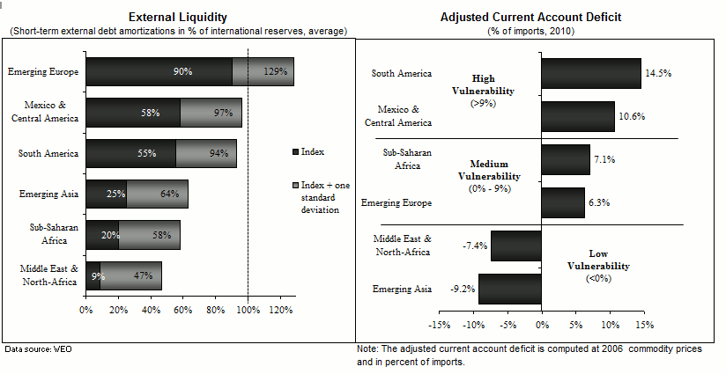
Although the majority of emerging countries are highly shielded regarding external liquidity risk, this is not the case when the vulnerability to macroeconomic risks is factored into the analysis. In spite of a strong external liquidity position, an outbreak of a more resistant strain of the Lehman-type virus would require many emerging countries to undergo severe macroeconomic adjustments such as output contraction, rise in unemployment, deterioration in fiscal balances, potentially non-convergent debt dynamics, weakening of banks’ balance sheets, and a credit crunch. In other words, emerging economies could be mired in problems associated with a sharp deterioration of economic fundamentals (see for example Calvo et al 2006 and Reinhart and Rogoff 2009).

Figure 3 (right panel) depicts a situation in which Latin American countries display the highest levels of macroeconomic vulnerability, with the exuberant South American region leading the pack and Mexico and Central American region a close second. Surplus regions, ie, emerging Asia and the Middle East and North Africa, display the lowest levels of vulnerability, while emerging Europe and sub-Saharan Africa are located in between. These regional patterns are also displayed by the majority of the individual countries within these regions.

Moreover, exuberant regions such as South America and sub-Saharan Africa, with positive values of the index, display the largest increases in macroeconomic vulnerability to adverse global conditions. In fact, these two regions are now much more vulnerable than they were at the beginning of the global financial crisis. In contrast, anaemic regions such as emerging Europe and Mexico and Central America display similar levels of macroeconomic vulnerability as they did in 2006. More generally, Figure 4 illustrates the positive relationship between the degree of macroeconomic exuberance (as measured by the index), and the increase in external macroeconomic vulnerability to adverse global conditions.
Figure 4. The exuberance-vulnerability paradox
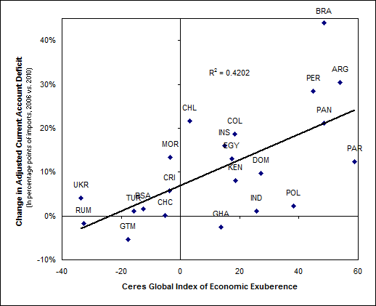

The exuberance-vulnerability paradox and the G20
Ironically, exuberance breeds vulnerability. Most of the emerging world turned out to be winners in the post-financial crisis economic geography, in several cases displaying an extraordinary degree of economic exuberance. However, many emerging markets are at the same time highly vulnerable to severe macroeconomic adjustments, should disarray in global capital markets – brought about by a new economic geography in which advanced economies are plagued with financial and sovereign debt problems – hit the world economy.
G20 leaders meeting in Cannes should be well aware of this peculiar connection between exuberance and vulnerability in emerging markets.

Policy conclusions
First, governments running exuberant emerging economies should note this exuberance-vulnerability paradox when setting their monetary, fiscal, and macroprudential policies.
Second, the international community, which in early 2009 acted in swiftly to increase the firepower of the IMF and other multilateral institutions to avoid a fallout of fundamentally sound but vulnerable emerging economies, should ensure that these institutions are adequately capitalised and able to perform the same role in the event of a new episode of global financial turmoil. This is a particularly relevant consideration at a time when the resources of the IMF might be strained by the Eurozone crisis.
Finally, the exuberant. cash-rich emerging-market players who were the key beneficiaries of the new global economic geography have high stakes in ensuring that the current global order is not disrupted by a new and perhaps more virulent strain of the Lehman-type virus.
Editor’s Note: This article is based on CERES’s recent report on Latin America’s Macroeconomic Outlook from a Global Perspective “Anemia, Exuberance and Vulnerability: the New Global Economic Geography”.

References
Calvo, G, A Izquierdo and E Talvi (2003), “Sudden Stops, the Real Exchange Rate and Fiscal Sustainability: Argentina’s Lessons”. NBER Working Paper 9828.
Calvo, G, Izquierdo, A and E Talvi (2006), “Phoenix Miracles in Emerging Markets: Recovering without Credit from Systemic Financial Crises”. NBER Working Paper 12101.
Guidotti, P (2000), “On Debt Management and Collective Action Clauses”. Kenen P. and A. Swoboda (editors). Reforming the International Monetary and Financial System, International Monetary Fund.
Economist (2011). “Temperature Gauge”, Daily Chart, 30 June.
Greenspan, A (1999), “Currency Reserves and Debt”. Speech before the World Bank Conference on Recent Trends in Reserves Management, Washington DC.
Izquierdo, A, and E Talvi, coordinators (2011), “One Region, Two Speeds? Challenges of the New Global Economic Order for Latin America and the Caribbean.” Monograph. Inter-American Development Bank.
Reinhart C and K Rogoff (2009), This Time is Different: Eight Centuries of Financial Folly, Princeton, NJ: Princeton University Press.
Rodrik, D and A Velasco (1999). “Short-Term Capital Flows”. NBER Working Paper 7364.

¹ The Economist (2011) recently published an Overheating Index. Our index has three key differences with the Overheating Index. First, the rationale: Our index attempts to identify winners and losers in the aftermath of the global financial crisis and thus, to measure the current situation relative to pre-crisis trends, independently of any notion of overheating. Second, it includes a different set of variables (and in some cases a similar variable computed in a different way). Third, the country coverage is significantly larger and also includes advanced economies.
² Cluster analysis is performed along the lines of Izquierdo and Talvi (2011).
³ The adjusted current account balance is measured as follows. First, it is computed at 2006 export and import prices to allow for a potential decline in commodity prices in the event of a Lehman-type episode. Second, it is measured in terms of imports, to obtain a more accurate gauge of the decline in domestic demand necessary to close any given current account deficit.

