China’s dominance hypothesis and the emergence of a tripolar global currency system
Marcel Fratzscher Arnaud Mehl
15 December 2011

Is the international monetary system tripolar – with the US dollar, the euro, and the Chinese renminbi at each corner? This column presents empirical evidence to suggest that the renminbi is already well on its way to being the dominant currency in Asia.

The 2007–08 global financial crisis has brought the reform of the international monetary system back to the forefront of the international policy debate. Some G20 leaders, notably from emerging economies, are questioning the configuration of the current system based on a single currency, the US dollar, as global reference currency, and the euro, as a more regional currency. Not only was the US the origin of the financial crisis, and Europe the first continent to be engulfed in the subsequent sovereign debt crises, but many link the global financial crisis to the US dollar’s dominant role, to the ‘exorbitant privilege’ it gives to the US (see eg Gourinchas and Rey 2007, Curcuru et al 2008) and ensuing lack of policy discipline, and to the negative global externalities it creates.
A multipolar international monetary system is deemed by many as a distant prospect (see eg Kenen 2011), but others expect it to unfold soon as a natural outcome of the emergence of Asia as the world economy’s powerhouse (see eg Eichengreen 2009 and 2010). As the story goes, the Chinese renminbi may emerge as a truly global currency, along with the euro, while the US dollar would lose its dominant status.
In recent research (Fratzscher and Mehl 2011) we assess to what extent a tripolar international monetary system has already emerged along with its implications for the global economy and financial markets. We test what we call ‘China’s dominance hypothesis’, ie whether the renminbi is already the dominant currency in Asia, exerting a large influence on exchange rate and monetary policies in the region, as much as China exerts a large influence on its neighbours through the well-known ‘Asian production chain’ or ‘Asian supply chain’.
Our focus is rooted in the fact that there is, somewhat paradoxically, a strong sense of déja vu in today’s debate on the future of the international monetary system, a debate remarkably reminiscent of a much older one that took place in Europe in the 1980s and 1990s, about the ‘German dominance hypothesis’. Back then, the international monetary system was already dominated by the US dollar. De jure, the European currencies were linked to each other under the European Monetary System. De facto, the system was markedly asymmetric, with Germany’s deutsche mark playing a dominant role, and other European currencies shadowing the German currency. The proponents of the ‘German dominance hypothesis’ saw this as a coercive arrangement that forced other countries to follow the disciplinary, low-inflation monetary policy of the Bundesbank (eg Giavazzi and Pagano 1988, Gros and Thygesen 1988, and von Hagen and Frattianni 1990). Reducing Germany’s dominance through a sharing of its monetary supremacy was, in the view of several European countries, a prime motivation to create the euro.
There are important similarities with Asia’s situation today. De jure, emerging Asian economies peg their currencies to the US dollar in a “Revised Bretton Woods system” or an “East Asian dollar standard” (Dooley et al 2004). De facto, Asian economies are highly dependant on China, by far the region’s largest economy. The mesh of real and financial linkages woven under the Asian production chain encourages economies to maintain their external competitiveness relative to China and the stability of their currency relative to the renminbi. In turn, this suggests that China’s exchange rate and monetary policy, together with the reforms since mid-2005 to increase FX flexibility, are likely to exert a significant – if not dominant – influence on exchange rate and monetary policies elsewhere in emerging Asia.¹
Our research tries to gauge how strong the influence of China’s FX policy already is on countries in the region, hence our analogy to the German dominance hypothesis. As noticeable as the parallels between Europe yesterday and Asia today may be, however, the China dominance hypothesis is not as easily testable as the German one. China’s (crawling) peg to the US dollar creates an identification problem, while the renminbi is not convertible and the capital account remains largely closed. Short-term interest rates or money aggregates co-movements (used in the German dominance hypothesis literature) are uninformative since China’s money, credit, and other financial markets remain heavily regulated, segmented, or repressed.
To overcome these challenges, the authors carry out an unconditional analysis based on a three-factor model of exchange rates, comprising a US dollar factor, a euro factor, and a regional currency factor for a set of 48 currencies of advanced and emerging economies. Overall, we find evidence in line with China’s dominance hypothesis, albeit with some qualifications, which suggests that the international monetary system is already on the verge of being tripolar. We identify a statistically significant regional FX factor in emerging Asia’s exchange-rate dynamics, which is stronger than in any other regions of the world. Table 1 reports the factor model estimates and indeed shows that Asia’s regional factor, with a loading of over 0.2, is the world’s largest, underscoring the strong regional orientation of exchange-rate policy in the area.
Importantly, we show that this factor has risen markedly in magnitude since China started its exchange-rate reforms in 2005. This is supportive of the view that emerging Asia’s policymakers have been paying more attention to regional currency developments since China gradually strengthened its exchange-rate flexibility. Our additional estimates suggest that this Asian regional foreign-exchange factor is mainly driven by the renminbi, although there is also evidence that causality is to some extent bi-directional and that the movements in Asia’s regional factor also partly steer those of the renminbi.
As a second approach, the authors conduct an event-study to analyse how shocks to China’s foreign-exchange regime impact exchange rates within Asia as well as globally, exploiting the foreign-exchange market reaction to official statements on exchange rate and reserve policy made by Chinese authorities. Figure 1 shows the average impact (in percentage) of an official Chinese statement on the day it occurs (with the SDR used as the numéraire currency). The Figure shows that the responses of Asian currencies are more similar to that of the renminbi itself than the responses of currencies of advanced economies or other EME regions (barring the Gulf Cooperation Council countries, which have strict peg to the US dollar). This is fully consistent with the unconditional analysis’s finding that the regional factor loading within Asia is substantial, implying that other Asian currencies closely co-move with the renminbi.
These findings raise a number of questions. One particular question concerns the optimality of current foreign-exchange configurations in Asia and whether the fact that countries focus their exchange-rate policy vis-à-vis a currency from outside the region, such as the US dollar, is optimal or whether stronger explicit exchange-rate coordination at the regional level might be beneficial. This is indeed what Europe’s experience in the 1980s and 1990s would suggest. As China continues to reform its exchange-rate regime in the years ahead, it is well possible that such a question could be of increasingly pressing policy interest, both for Asia and globally.
Table 1. Global exchange rate factor model– Full sample estimates(by country group/region)
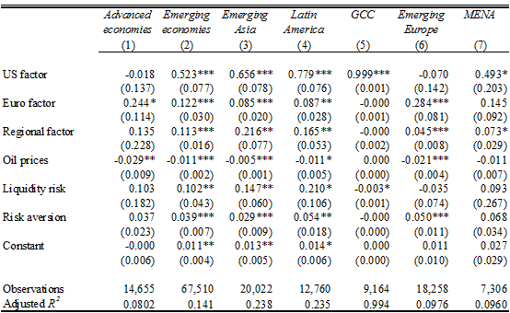
Note: Pooled OLS estimates of a three-factor model for each of the sample’s country groups or regions. Robust standard errors are reported in parentheses. (***), (**) and (*) denote statistical significance at the 1%, 5% and 10% level of confidence, respectively. GCC = Gulf Cooperation Council; MENA = Middle-East and Northern Africa.
Figure 1. Average impact of Chinese official statements on global FX markets (breakdown by currency; SDR as numéraire currency; in %)
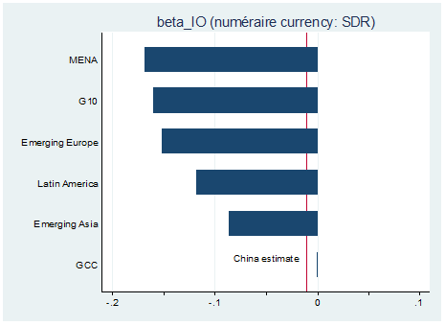
Note: The Figure shows the average impact (in %) of official statements by Chinese policymakers on exchange-rate/reserve allocation policy on a sample of 48 currencies on the day the statement occurs. Estimates shown are equally-weighted averages for all currencies within a particular region or group. The SDR basket is used as numéraire. A negative entry indicates an appreciation of the respective currency vis-à-vis the SDR.

References
Curcuru, SE, T Dvorak and F Warnock (2008), “Cross-Border Returns Differentials,” Quarterly Journal of Economics, 123(4), pp. 1495–1530.
Dooley, MP, D Folkerts-Landau and P Garber (2004), “The Revised Bretton Woods System,” International Journal of Finance and Economics, 2004, Vol. 9(4) October, pp. 307-313.
Eichengreen, B (2009), “The Dollar Dilemma: The World’s Top Currency Faces Competition”, Foreign Affairs, 888(5), pp. 53-68.
Eichengreen, B (2010), Exorbitant Privilege – The Rise and Fall of the Dollar and the Future of the International Monetary System, Oxford University Press, December 2010.
Fratzscher, M and A Mehl (2011),“China’s Dominance Hypothesis and the Emergence of a Tri-polar Global Currency System”, CEPR Discussion Paper, No. 8671, November 2011.
Giavazzi, F and M Pagano (1998), “The Advantage of Tying One’s Hands: EMS Discipline and Central Bank Credibility,” European Economic Review, May 1988, 32, pp. 1055-1082.
Gourinchas, P-O and H Rey (2007), “International Financial Adjustment,” Journal of Political Economy, pp. 665–703.
Gros, D and N Thygesen (1988), “Le SME: performances et perspectives,” Observations et diagnostiques économiques, January 1988, 24, pp. 55-80.
Kenen, P (2011), “Beyond the Dollar”, paper presented at the AEA Allied Social Science Association Meetings, Denver, Colorado.
Von Hagen, J and Fratianni, M (1990), “German Dominance in the EMS: Evidence from Interest Rates”, Journal of International Money and Finance, 9, pp. 358-375.

¹ By no means does this necessarily imply that the renminbi’s influence in the region is or will be stronger than that of the US dollar. For instance, for Europe in the 1980s, it was found that while German interest rate movements had the strongest effect on interest rates of all countries in the continent, US interest rates had also retained a significant effect. The concept of a country’s dominance is a relative one, and it can still exist alongside that of another country that also exerts strong influence. This may be the case of the renminbi indeed. While it may not dominate the US dollar’s impact on Asian economies, it may nevertheless exert a large and rapidly growing impact on the region

Top of Form
Bottom of Form

