Foreign banks: Trends and impact on financial development

Stijn Claessens Neeltje van Horen
28 January 2012

Foreign banks on domestic soil have always been controversial. This column presents a newly collected, comprehensive database on bank ownership for 137 countries over the period 1995–2009. It shows that current market shares of foreign banks average 20% in OECD countries and 50% elsewhere. In developing countries, however, foreign bank presence is correlated with less private credit.

Although interrupted by the recent financial crisis, the past two decades have seen an unprecedented degree of globalisation, especially in financial services. Cross-border bank and other capital flows have increased dramatically. Many banks have ventured abroad and established a presence in other countries. This has happened among EU countries (Allen et al 2011), but especially in emerging markets and developing countries. While Western banking groups were most active as investors, also many banks from emerging economies have ventured abroad (van Horen 2006, 2011). Although there are exceptions and regional differences, few countries have been left out from this trend of increasing financial integration.

The recent crisis has highlighted, however, that while foreign banks play important roles in the global financial system, it is not well understood how they affect domestic financial systems, access to financial services, lending stability, and consequent economic performance. This is in part because data availability has been limited. Many studies to date have only used short time periods and a limited number of countries, and hardly any have investigated the bilateral dimension of foreign ownership. Given the importance of foreign banks in many countries, understanding the motivations of foreign banks to enter a particular host country, the mode by which they do so, how they differ from domestic banks, and the impact they have on financial-sector development and lending stability have become essential. A new data effort can help provide answers to some of these questions.

Trends in foreign bank investment
Recently, a new, comprehensive database on bank ownership, identifying also the home country of foreign banks, for 137 countries over the period 1995–2009, has been completed, with key facts summarised in our overview paper (Claessens and van Horen 2012). The data show some salient trends. Our paper documents that, albeit interrupted by the global financial crisis, foreign bank presence, in terms of number and share among domestic banks, has increased substantially in most countries over the past three decades (Figure 1). Sometimes increases have been from zero to foreign banks holding 67% market share (in terms of numbers) in a single decade. As Figure 2 shows, not many countries have been left out from this trend, but substantial differences still exist. At the same time, many more home countries have become active as investors, with several emerging countries becoming important ‘exporters’.

State of affairs
Taking stock as of end 2007 – just before the crisis – foreign banks capture on average about 20% of market shares, in terms of loans, deposits and profits, in OECD countries and close to 50% in emerging markets and developing countries. Moreover, in those countries with majority foreign banks in numbers, foreign banks tend to be more important in intermediation. In contrast, when less important in numbers, foreign banks tend to be niche players. Foreign ownership, however, is mostly regional. This pattern has actually become stronger over time with more banks from emerging markets, which have a stronger tendency to stay within their own geographical region, establishing a presence abroad.

Figure 1. Number and share of foreign banks, 1995–2009
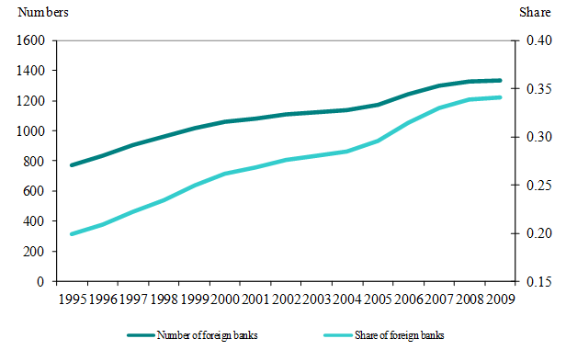
Figure 2. Relative foreign bank presence across host countries, 1995 and 2009
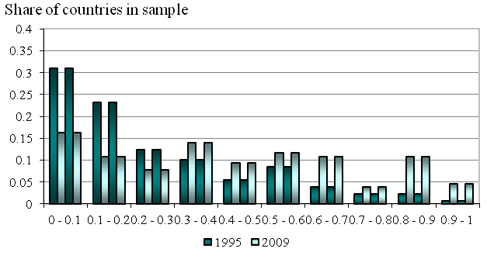
Note: The figure shows the relative importance of foreign banks in the host countries' banking systems . For each host country the share of foreign banks (in numbers) is determined in 1995 and 2009. The figure depicts the distributions of these shares.

Differences between domestic and foreign banks
Foreign banks differ from domestic banks in key balance-sheet variables. Notably, foreign banks have higher capital and more liquidity. In terms of performance, foreign banks underperform domestic banks in emerging markets and developing countries, but do not perform differently in high-income countries. These differences likely reflect in part variations in business strategies between foreign and domestic banks but also differences in host-country circumstances. Particularly, performance may differ because foreign banks have more conservative portfolios and operate with less ease in some countries than domestic banks do (see also Claessens and van Horen 2011). They also engage relatively less in traditional lending businesses, especially when smaller.

Impact of foreign banks on financial sector development
A crucial question has been the impact of foreign-bank activity on a host country’s financial development. Before the crisis, the general consensus was that the benefits greatly outweigh the costs in many dimensions. It was generally considered that foreign banks add to domestic competition, improve the quality of financial intermediation, increase access to financial services, enhance financial and economic performance of their borrowers, and bring greater financial stability (Cull and Martinez Peria 2011).

The effects of foreign banks on development and efficiency have been found to vary though. Limited general development and barriers can hinder the effectiveness of foreign banks. Also, the relative market share and size of foreign banks seem to matter. With more limited entry as a share of the total host banking system, fewer spillovers seem to arise. And larger foreign banks seem associated with greater effects on access to finance for small- and medium-sized enterprises, perhaps as they are more committed to the market. Furthermore, healthier home and local host banks show better credit growth. Some studies though find that foreign banks can have perverse effects. Because foreign banks ‘cherry-pick’ borrowers, they can undermine overall access to financial services, since cherry-picking worsens the remaining credit pool, and therefore lowers financial development, especially in low-income countries where relationship lending is important (Detragiache et al 2008).

Revisiting this literature on foreign banking using the newly assembled data, cross-country analysis shows that the relationship between foreign-bank presence and financial sector development indeed differs by host country. Specifically, in emerging markets and high-income countries, foreign-bank presence tends to have an insignificant relationship with credit extended. In developing countries, however, foreign-bank presence is associated with less overall credit extended. Indeed, in these countries a one standard deviation increase in the foreign-bank share is associated with a decline in private credit–to-GDP of 5 percentage points, economically very large, since the mean of private credit–to-GDP in this group of countries is only 19%. Of course, this is not necessarily a causal relationship.

In summary, while foreign bank presence could have a negative relationship with financial development, this is not a general result. Therefore, it is important to allow for differences in foreign bank presence, level of development, and other factors when considering the relationship between foreign banks, domestic credit creation, and other aspects of financial sector development.

References
Allen, Franklin, Thorsten Beck, Elena Carletti, Philip Lane, Dirk Schoenmaker, Wolf Wagner (2011), “Cross-Border Banking in Europe: Implications for Financial Stability and Macroeconomic Policies”, VoxEU.org, 20 June.
Claessens, Stijn and Neeltje van Horen (2010), “Being a Foreigner among Domestic Banks: Asset or Liability?”, forthcoming, Journal of Banking and Finance.
Claessens, Stijn and Neeltje van Horen (2012), “Foreign Banks: Trends, Impact and Financial Stability”, International Monetary Fund Working Paper 12/10
Cull, Robert and María Soledad Martinez Peria (2011), “Foreign Bank Participation in Developing Countries: What do We Know about the Drivers and Consequences of this Phenomenon”, forthcoming in Gerard Caprio (ed.), Encyclopedia of Financial Globalization.
Detragiache, Enrica, Poonam Gupta, and Thierry Tressel, 2008, “Foreign Banks in Poor Countries: Theory and Evidence,” Journal of Finance, 63, 2123-2160.
van Horen, Neeltje, 2006, “Foreign Banking in Developing Countries: Origin Matters,” Emerging Market Review, 8, 81-105.

van Horen, Neeltje (2011), “The changing role of emerging-market banks”, VoxEU.org, 25 October.

Top of Form
Bottom of Form

