The renminbi’s prospects as a global reserve currency

Eswar Prasad Lei (Sandy) Ye
16 February 2012

Is China’s currency destined to become the dominant global reserve currency? This column argues that despite not yet having a flexible exchange rate or open capital account, China’s government is pursuing ‘liberalisation with Chinese characteristics’. It argues that the renminbi will become a reserve currency within the next decade, eroding but not displacing the dollar’s dominance.

Popular discussions about the prospects of China’s currency – the renminbi – range from the view that it is on the threshold of becoming the dominant global reserve currency to the concern that rapid capital-account opening poses serious risks for China. A number of recent academic studies have pointed to the renminbi’s rising importance in the international monetary system, although these studies are divided on the renminbi’s prospects of becoming a dominant global reserve currency (see Eichengreen 2011, Frankel 2011, Fratzscher and Mehl 2011 on this site).

These are legitimate and important issues, as the rise of China’s economy and its currency have implications for global macroeconomic and financial stability. It is interesting that, of the currencies of the world’s six largest economies, China’s renminbi is the only one that is not a reserve currency. Even though the economy has neither a flexible exchange rate nor an open capital account, the Chinese government has recently taken a number of steps to increase the international use of the renminbi. Given China’s rising shares of global GDP and trade, these steps are gaining traction and signal a rising role for the renminbi in global trade and finance.

In recent research (Prasad and Ye 2011), we explore the prospect of the renminbi becoming a global reserve currency. The popular debate often conflates three related, but distinct, aspects of the renminbi’s role in the global monetary system:
- Internationalisation: Its use in denominating and settling cross-border trade and financial transactions, that is, its use as an international medium of exchange.
- Capital-account convertibility: The country’s level of restrictions on inflows and outflows of financial capital. A fully open capital account has no restrictions.
- Reserve currency: Whether the renminbi is held by foreign central banks as protection against balance of payments crises.
A currency’s international usage and its convertibility are different concepts, and neither one is a necessary or sufficient condition for the other. Both conditions have to be met, however, for a currency to become a reserve currency. We consider these aspects in turn.
China is promoting the international use of its currency by:
- Permitting the settlement of trade transactions with the renminbi.
- Easing restrictions on cross-border remittances of the renminbi for settlement.
- Allowing the issuance of renminbi-denominated bonds in Hong Kong and by foreigners in the mainland.
- Permitting selected banks to offer offshore renminbi deposit accounts.
- Setting up local currency bilateral swap lines with other central banks.
These steps are gaining traction – Figure 1 shows the expanding offshore use of the renminbi in various trade and finance transactions. The trajectory is steep in each of these categories, but the amounts are still modest. A big advantage for China is that Hong Kong provides an effective platform for launching these measures in an experimental manner without full capital-account opening. Some central banks are considering holding renminbi-denominated assets in their foreign exchange reserve portfolios.

Figure 1. Renminbi offshore developments (in billions of US dollars)
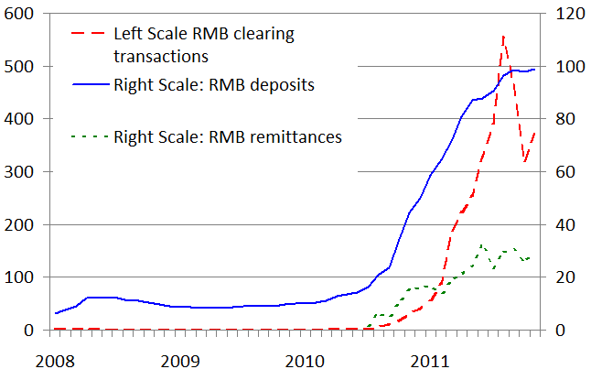
Source: Monthly data from CEIC and the Hong Kong Monetary Authority.
Note: Remittances data start from July 2010 and they represent RMB remittances for cross-border trade settlement.

All of these shifts are still modest in size and could soon hit their limits unless China’s capital account becomes more open.
The renminbi’s prospects as a reserve currency will be influenced by these criteria:
- Economic size: A country’s size and its shares of global trade and finance are important, but not crucial, determinants of its currency’s status as a reserve currency. China now accounts for 10% of world GDP (15% measured by purchasing power parity rather than market exchange rates) and 9% of world trade. In 2011, it is estimated to have accounted for about one quarter of world GDP growth.
- Open capital account: The currency must be easily tradeable in global financial markets with no restrictions on capital flows. China is gradually and selectively easing restrictions on both inflows and outflows. The capital account has become increasingly open in de facto terms, but extensive capital controls still prevail.
- Flexible exchange rate: Reserve currencies generally trade freely at market-determined exchange rates. It is worth emphasising that an open capital account is not synonymous with a freely floating exchange rate. China still has a tightly managed exchange rate, which will become increasingly hard to manage as the capital account becomes more open.
- Financial market development: A country must have broad, deep, and liquid financial markets so that international investors will have access to a wide array of financial assets denominated in its currency. China has relatively shallow and underdeveloped government and corporate bond markets (see Figure 2). Many other securities and derivatives markets are in their nascent stages.
- Macroeconomic policies: Investors in a country’s sovereign assets must have faith in its commitment to low inflation and sustainable levels of public debt. China has a lower ratio of explicit public debt-to-GDP than most major reserve currency economies and has maintained moderate inflation in recent years.

Figure 2. Domestic debt securities, 2010 (in trillions of US dollars)
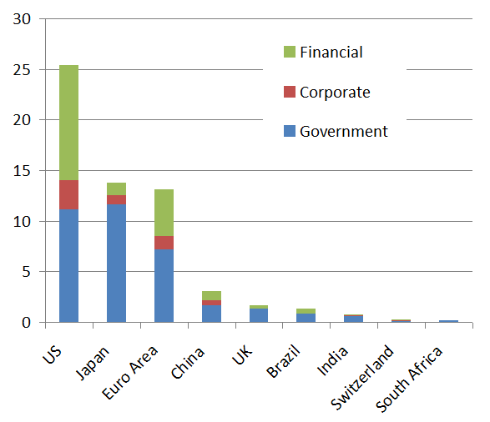
Source: BIS and authors’ calculations.
Notes: This figure shows the outstanding amount of domestic debt by residence of issuance and also by sectors of issuance. Euro area data do not include Estonia.
- There are no ironclad rules about the relative importance of and trade-offs among many of the factors listed a
bove. For instance, the Swiss franc is a global reserve currency even though Switzerland’s shares of global GDP and trade are quite modest. Moreover, the Eurozone, Japan and the US have large and rising public debt burdens, which raises questions about their macroeconomic stability but has not (yet) affected their currencies’ status as reserve currencies. Some analysts have in fact extrapolated from the US experience to argue that China must run large current-account deficits if it wants to provide reserve assets to the rest of the world. But this is neither a necessary nor sufficient condition for attaining reserve currency status.
Financial-market development in the home country is one of the crucial determinants of a currency’s international status. The relevant aspects of financial market development are the following:
- Breadth: The availability of a broad range of financial instruments, including markets for hedging risk.
- Depth: A large volume of financial instruments in specific markets.
- Liquidity: A high level of turnover (trading volume).
Without a sufficiently large debt market, the renminbi cannot be credibly used in international transactions. If there is insufficient liquidity in markets for renminbi-denominated assets, the currency will not be attractive to foreign investors. Other central banks and large institutional investors will demand renminbi-denominated government and corporate debt as ‘safe’ assets for their portfolios. At the same time, both importers and exporters may be concerned about greater exchange-rate volatility resulting from an open capital account if they do not have access to derivatives markets to hedge foreign exchange risk.
In addressing the reserve currency criteria vis-à-vis the renminbi, China faces two major challenges:
- Sequencing of capital-account opening with other policies, such as exchange-rate flexibility and financial market development, to improve the cost/benefit trade-off.
- Financial-market development – strengthening the banking system; developing deep and liquid government and corporate bond markets, as well as foreign exchange spot and derivative markets.
China’s ability to meet these challenges will determine the balance and sustainability of its economic development, as well as the renminbi’s role in the global monetary system.
Given its size and economic clout, China is adopting a unique approach, which we refer to as ‘capital account liberalisation with Chinese characteristics.’ We anticipate the following outcomes:
- The government’s medium-term objective, which we believe will be achieved in the next five years, is an open capital account but with numerous ‘soft’ controls. This will allow the currency to play an increasingly significant role in global trade and finance without relinquishing all control over capital flows.
- The renminbi will be included in the basket of currencies that make up the International Monetary Fund’s Special Drawing Rights basket within the next five years.
- Although China’s rapid growth will help promote the international use of its currency, its low level of financial market development greatly constrains the renminbi’s attainment of reserve currency status.
- The renminbi will become a reserve currency within the next decade, eroding but not displacing the dollar’s dominance.

References
Eichengreen, Barry (2011), “Dollar: Dominant no more?”, VoxEU.org, 10 January.
Frankel, Jeffery, 2011, “The rise of the renminbi as international currency: Historical precedents,” VoxEU.org, 10 October.
Fratzscher, Marcel, and Arnaud Mehl (2011), “China’s dominance hypothesis and the emergence of a tripolar global currency system”, VoxEU.org, 15 December.

Prasad, Eswar and Lei (Sandy) Ye (2011), “The Renmibi’s Role in the Global Monetary System”, IZA Discussion Paper Series No. 6335.

Top of Form
Bottom of Form

